OOR / Ontohub API

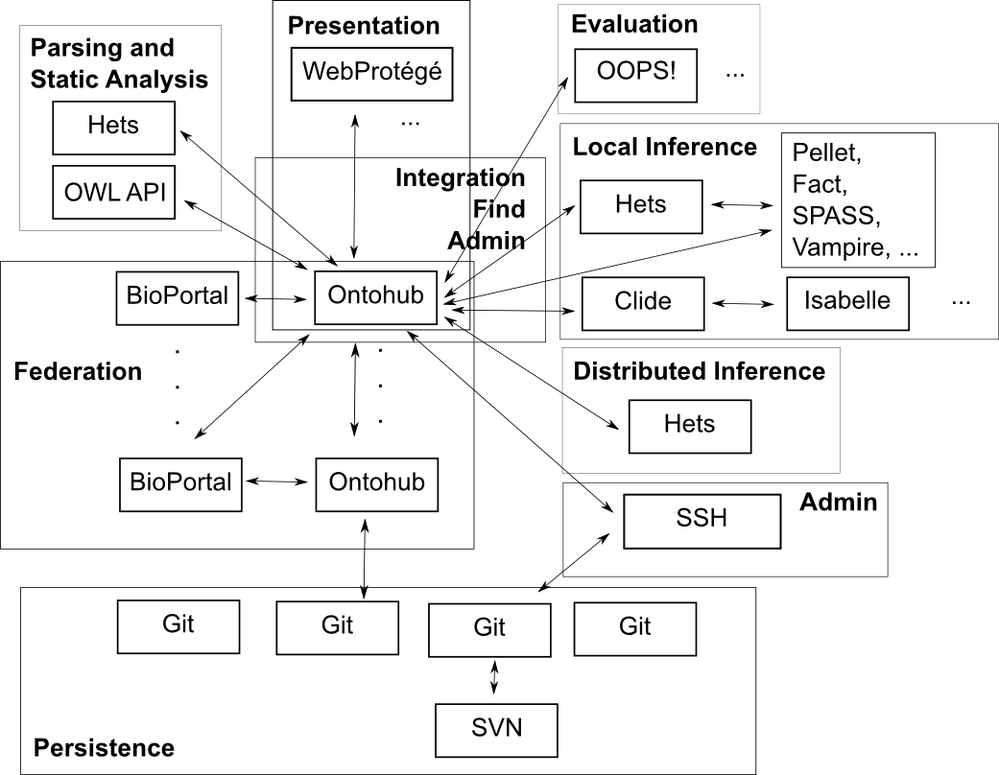

Federation and general
General remark: Any ontology and any link can be optionally accompanied by a version id.
Ontology ids are instance specific

Logic Services
- List all ontology languages () => (list (language id:name))
- List all supported logics of language (language id) => (list (logic id:name))
- List all serializations of language (langauge id) => (list (serial.id:name))
- List all logic translation () => (list (logic-translation id:name))
- List all logic translation with source (logic id) => (list (logic-translation id:name))
- List all logic translation with target (logic id) => (list (logic-translation id:name))
- List all ontology language translations
- List all ontology language translations with a given source
- List all ontology language translations with a given target

Ontology Services
vid = version id
sid = serialization id
blue = formalized in OORService (see below)
pink = not formalized in OORService
Method Name
- List all ontology latest versions find Latest OntologyVersions
- Get ontology latest version index Ontology derived
- Get ontology version metadata index OntologyVersion
- Get ontology symbols and sent. find Ontology SymbolsAndSentences derived
- Get o. version symbols and sent. find OntologyVersion SymbolsAndSentences
- Get ontology latest version metadata get Ontology Metadata derived
- Get an ontology version file get OntologyVersion File
- Get the ontology last version file get Ontology File derived
- Get metrics for an ontology version get OntologyVersion Metrics
- Get all ns prefixes of ontology get Ontology Prefix
- List all ontology categories list Categories
- List all ontologies for a category find Category Ontologies
- List all ontology-using groups list Groups
- List all ontologies, given a language find Language Ontologies
  - (the language can be DOL, in the case, list all distributed ontologies)
- Given a distributed ontology, list all component ontologies and links
- Given an ontology or link, list all distributed ontologies it belongs to
- Get all comments/notes/proposals of an ontology
- Add a comments/notes/proposals to an ontology

Not formalized in OORService
index OntologyVersion (ontology[id,vid]) => (ontology)
find Ontology SymbolsAndSentences
(ontology[id]) => (list(symbol), list(sentence))
find OntologyVersion SymbolsAndSentences
(ontology[id,vid]) => (list(symbol), list(sentence))
get Ontology Prefix (ontology[id]) => (prefix)
list Categories () => (list (category[id,name])
find Category Ontologies (category[id]) => (list (ontology[id,name])
list Groups () => (list (group[id,name])
find Language Ontologies (language[id]) => (list (ontology[id,name])

upload OntologyVersion (ontology[id],file) => (vid)
download OntologyVersion (ontology[id,vid]) => (file)

Formalized in OORService
# not to be implemented in our system

Ontology
find Ontology (name-fragment) => (list (ontology[id,name]))
create Ontology (ontology) => (ontology[id])
index Ontology (ontology[id]) => (ontology)
update Ontology (ontology) => ()
delete Ontology (ontology[id]) => ()

get OntologyVersion Metrics (ontology[id,vid]) => (metrics)
update OntologyVersion Metrics (ontology[id,vid],metrics) => ()
extract OntologyVersion Metrics (ontology[id,vid]) => (metrics)

get OntologyVersion File (ontology[id,vid,sid]) => (file)
find Latest OntologyVersions
find Latest ActiveOntologyVersions

Note/Comment
get AllNotes ForOnto (ontology[id]) => (list (note))
get AllNotes ForOnto ByAuthor (o[id], author[id]) => (list (note))
get AllNotes ForConcept (o[id], concept[id]) => (list (note))
get AllNotes ForIndividual (o[id], indiv.[id]) => (list (note))
get AllNotes ForNote (o[id], note[id]) => (list (note))
create Note
update Note
archive Note
delete Note
unarchive Note
get Note Bean
get RootNote
archive Thread
unarchive Thread

Project
create Project
retrieve Project
update Project
delete Project

Review
create Review
retrieve Review
update Review
delete Review
get Reviews ForOnto

Rating
create Rating
update Rating
delete Rating
get AllRatingTypes
retrieve RatingType

Finding Commands
find OntologyOrView => find Ontology
find LatestActiveOntologyVersions => find LatestActiveOntologyVersions
find LatestOntologyVersions => find LatestOntologyVersions

cleanupOntologyCategory
getOntologyFile

Mapping Services
- Get a single mapping by its id. Return type of mapping and list of mapping elements
- Get a list of mappings filtered by parameters
- Get a list of mappings for a symbol
- Get a list of mappings between two symbols
- Get a list of mappings for an ontology
- Get a list of mappings between two ontologies
- Create a new mapping
- Update a Mapping
- Delete a Mapping
- Mapping Statistics
- Get Recent Mappings
- Get Number of Mappings To/From Given Ontology
- Get Number of Mappings to Terms in Given Ontology
- Get Number of Mappings by Users for a Given Ontology

Parsing and Static analysis
- Get all kinds of symbols (for a given ontology language),
- Parse an ontology file and get all symbols and axioms (in a specific language)
- Parse a DOL file and get all ontologies and links of the distributed ontology (this implicitly includes computation of ontologies specified by the DOL structuring constructs, e.g. ontology combinations)
- Translate an ontology along a logic or language translation

Search
There is only one method (search), having the following parameters:
- search string (with Boolean operators and wildcards, e.g. "foo bar -baz" will expand to "foo* AND bar* AND NOT baz*")
- ontologyids=<ontologyid>,<ontologyid>… - limits the search to specific ontologies (default: all ontologies)
- searchontologynames=[1/0] – search in the ontology names (default: 1)
- searchsymbolnames=[1/0] – search in the symbol names (default: 1)
- isexactmatch=[1/0] – match the entire ontology resp. symbol name (default: 0)
- pagesize=<pagesize> - the number of results to display in a single request (default: all)
- pagenum=<pagenum> - the page number to display (pages are calculated using <total results>/<pagesize>) (default: 1)
- maxnumhits=<maxnumhits> - the maximum number of top matching results to return (default: 1000)
- symbolkinds=<kind,kind,..> - limits the results returned to these kinds, multitple kinds can be included in the parameter.
- includedefinitions={true} - if a search result is a hit for a symbol, adding this parameter will include the definition in the search result xml.

Persistence
- Synchronize two repositories (also non-git ones, like triple stores)

Difference
createDiff
createDiffForLatestActiveOntologyVersionPair
createDiffForAllActiveVersionsOfOntology
getAllDiffsForOntology
getDiffFileForOntologyVersions

Local Inference
- get available inference tools by name, language/logic, type (prover, model finder, conservativity checker, module extractor) and input parameters (including options)
- prove open goals in an ontology. Output: list of used axioms, proof, proof status using SZS ontology http://tinyurl.com/szsontology
- check consistency / find model of an ontology. Output: model, represented by symbols + axioms
- disprove open goals in an ontology. Output: see find model
- check conservativity of a link. Output: conservativity status (NotCons, DontKnow, Cons, Mono, Def)
- module extraction for an ontology w.r.t. a subsignature=list of symbols and an extraction algorithm

Distributed Inference
Open questions: should we use Hets development graph sessions, or send around (updates to) distributed ontologies (consisting of ontologies and links)? The latter needs a distributed ontology closed under the import/definition link relation - this can become quite large. (Should we therefore allow distributed ontologies to import other distributed ontologies?) Should a new proof state of a distributed ontology constitute a new version, possibly with new version of the
involved ontologies and links?
What happens with proof goals generated e.g. by interpretations? Can they spoil the target ontology?
How can we avoid that Hets needs to read in every new version of the distributed ontology from scratch? (Hets would need a caching mechanism.)

Here is the session based API:
- POST /libraries/<coded-iri>/sessions - create a new proof session for development graph
- GET /sessions/<id>?format=<f> - get proof state of session
- GET /menus - Get development graph menu structure
- GET /nodes/<coded-iri>?library=<coded-iri>&session=id - Get info for node
- GET /nodes/<coded-iri>/theory?library=<coded-iri>&session=id - Get theory of node
- GET /edges/<coded-iri>?library=<coded-iri>&session=id - Get info for edge
- PUT /libraries/<coded-iri>/proofs/<id>/<command> - execute command for session
- PUT /sessions/<id>/<command>?node=<iri>&edge=<iri>- execute command for node in session
- GET /sessions/<id>/provers?node=<iri>&translation=<iri> - Get provers for node
- GET /sessions/<id>/translations?node=<iri> - Get logic translations for node
- PUT /sessions/<id>/prove?node=<iri>?prover=<name>&translation=<iri> &timeout=<secs>&include=true - Call prover
List of available Hets commands (which ones do we need here?)
dg-all auto Apply automatic tactic - needed
dg-all glob-decomp Apply rule global-decomposition - to start with, auto should suffice
dg-all global-subsume Apply rule global-subsumption - to start with, auto should suffice
dg-all loc-decomp Apply rule local-decomposition - to start with, auto should suffice
dg-all local-infer Apply rule local-inference - to start with, auto should suffice
dg-all comp prove composed edges - to start with, auto should suffice
dg-all comp-new create composed proven edges - to start with, auto should suffice
dg-all cons Apply rule conservativity - to start with, auto should suffice
dg-all hide-thm Apply rule hide-theorem-shift - to start with, auto should suffice
dg-all thm-hide Apply rule theorem-hide-shift - to start with, auto should suffice
compute-colimit compute colimit - not needed, since this is called by static analysis of “combine”
compute-normal-form Compute normal forms for nodes with incoming hiding links - needed for proving in presence of hiding
triangle-cons triangle-cons - needed
freeness freeness - not needed in DOL
flattening importing Flatten all theories and delete all importing links - needed for interfacing to standard theorem provers
flattening disjoint-union Create intersection nodes and ensure only disjoint unions - needed for interfacing to some (but not many) theorem provers
flattening renaming Flatten out renaming - needed for interfacing to some (but not many) theorem provers
flattening hiding Delete all hiding links - needed for interfacing to some (but not many) theorem provers
flattening heterogeneity Flatten out heterogeneity - needed for interfacing to some (but not many) theorem provers
qualify-all-names Qualify and disambiguate all signature names
undo Undo last change - not needed
redo Redo last change - not needed
use <File> Read HetCASL file - not needed
dg basic <Nodes> Select node - needed
translate <Comorphism> Choose translation - needed
prover <Prover> Choose prover - needed
set goals <Goal> Set goal - needed
prove Applies selected prover to selected goals - needed
check-consistency check consistency - needed
drop-translations Drops any selected comorphism - needed
cons-checker <ConsChecker> Choose consistency checker - needed
conservativity-check <Edges> Choose conservativity checker - needed
set time-limit <Number> Set the time-limit for the next proof - needed
set axioms <Axiom> Set the axioms used for the next proof - needed
set include-theorems true Include proven theorems - needed
set include-theorems false Do not include proven theorems - needed
nodes Show Nodes - not needed
edges Show Edges - not needed
show-undo-history Show Undo-History - not needed
show-redo-history Show Redo-History - not needed
show-proven-goals-current Show Proven Goals of selected node - needed
show-unproven-goals-current Show Unproven Goals of selected node - needed
show-all-axioms-current Show All Axioms of selected node - needed
show-all-goals-current Show All Goals of selected node - needed
show-computed-theory-current Show Computed Theory of selected node - needed
show-taxonomy-current Show Taxonomy of selected node - not needed
show-concept-current Show Concept of selected node - not needed
show-node-info-current Show Node-Info of selected node - needed
show-node-info <Nodes> Show Node-Info - needed
show-computed-theory <Nodes> Show Computed Theory - needed
show-all-goals <Nodes> Show All Goals - needed
show-proven-goals <Nodes> Show Proven Goals - needed
show-unproven-goals <Nodes> Show Unproven Goals - needed
show-all-axioms <Nodes> Show All Axioms - needed
show-taxonomy <Nodes> Show Taxonomy - not needed
show-concept <Nodes> Show Concept - not needed
show-edge-info <Edges> Show Edge-Info - needed
expand Extend current node - ???
addview Add a view - ???
help Show all available commands - see DG menus?
quit Quit - not needed

Here is an API for sending around updates:
- prove link. Input: IRI of link. Output: list of new links and/or proof goals for simple ontologies that will prove the link

Evaluation and other services

OOPS! and similar services
we propose the following abstraction from the OOPS! API:
input: ontology
output: list of response elements of the following form:
type (for OOPS: pitfall, warning, suggestion)
code (an integer)
name
description
list of involved symbols

Annotator Service

This service it specific to bio ontologies. How to generalise it to other domains? It seems that some (more static) list of service types and (more dynamically growing) list of actual services (conforming to these service types) would be useful. This of course also includes services like OOPS!

Ontology Recommender

Interesting challenge to generalise this to ontologies written in arbitrary languages...

Resource Index Service

could be adapted for Ontohub, if "concept" is replaced by "symbol"

Notes Service (Term Proposals and Comments)

Logic-specific services
OWL specific services involving the class hierarchy
These services could also be used for other languages if there is a suitable projection to OWL.

Remaining stuff from OOR
find AllOntologyOrViewVersionsByVirtualId#
find LatestAutoPulledOntologyVersions#
find LatestActiveOntologyOrViewVersion#
find LatestActiveOntologyViewVersions#
find LatestOntologyOrViewVersion#
find LatestOntologyViewVersions#

OOPS! has more inputs, but we let the list of pitfalls empty, and the output format be XML.
OOPS! outputs structured XML elements that may contain multiple n-ary relations between symbols (e.g. oops:MightBeEquivalentProperty and oops:MightBeEquivalentAttribute). We prefer to have only one such relation per response element.

